China Mid-Autumn Festival

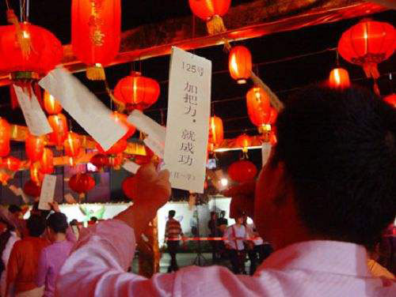

The festival is celebrated at the 15th day of the eighth lunar month in China. On this day, the moon is believed to be the brightest and biggest in the whole year. The festival represents the unity and leisure of the people, as well as the harvest of the nature.

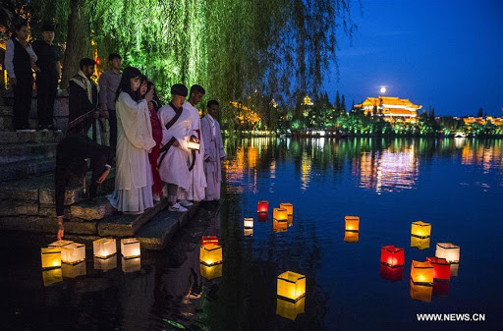

The Mid-autumn Day could be dated back to the beginning of Tang dynasty,and became prevalent in the Song dynasty. It has took form into a main festival which as important as spring festival when it came to Ming and Qing dynasty. With a deep-rooted influence to those neighboring countries , it is a important festival in southeast Asia,especially to overseas Chinese.On May 20th,2006,it was added on the list of Chinese national intangible culture heritages. Nowadays, the Mid-autumn festival has been called the top four traditional festivals in china together with the Dragon Boat day,the Tomb Sweeping day and the Spring festival.

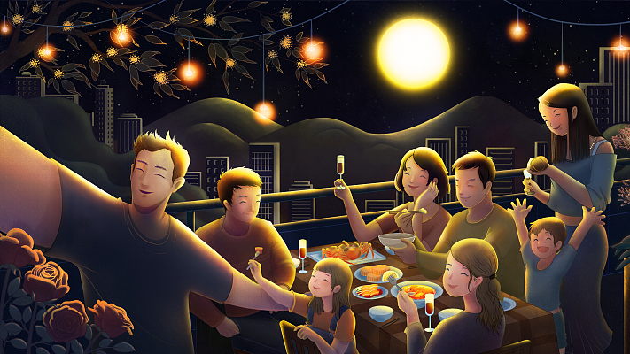

The custom of worshipping the Moon can be traced back as far as Xia and Shang Dynasties (2000 B.C. - 1066 B.C). Today, Chinese people send their relatives and friends moon cakes as festival gift to extend their best wishes of union when the day is drawing near.

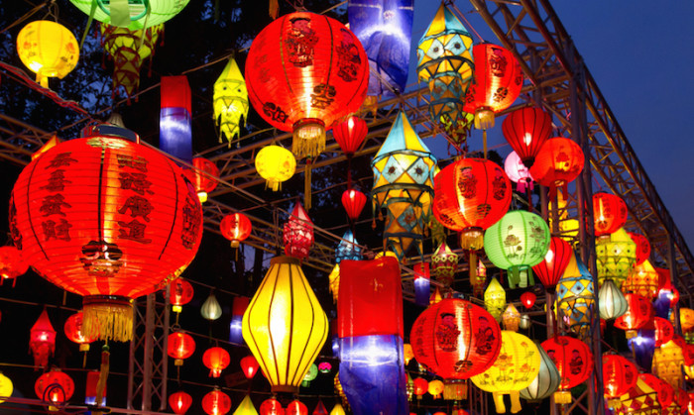

They are supposed to enjoy themselves under the silver moonlight outside eating the moon cakes and appreciating the full bright moon in the evening of the festival. If one of the family members is far away on duty and fail to come home at the festival, he or she will convey the homesickness and missing through the moon. Therefore, the moon has become a medium of communication and spiritual sustenance.

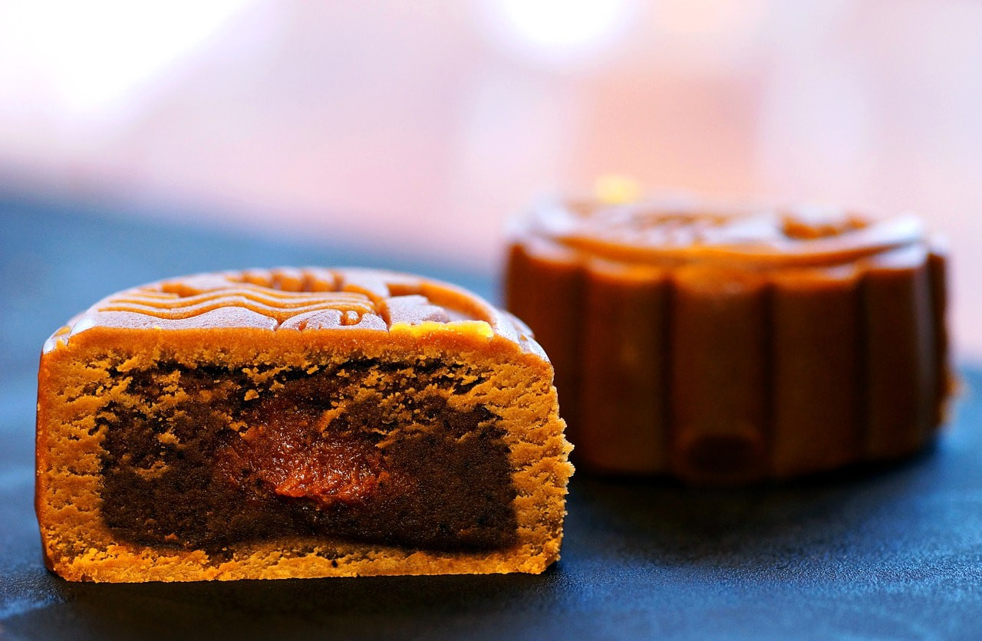

Besides worshiping the moon, watching the tides has also been a quite exciting thing to do in southern china on this day.As during this festival has the biggest moon over the year, so it brings in the most magnificent tides in the whole year.Many Chinese gather and crowd at Qiantang River s best sight just to be a witness of this magnificent bore during mid-autumn day every year in China.